**INTI International College Penang School of Engineering and Technology**

**3+0 Bachelor of Science (Hons) in Computer Science, in collaboration with Coventry University, UK**

**3+0 Bachelor of Science (Hons) in Computing, in collaboration with Coventry University, UK**

**Coursework cover sheet**

## **Section A - To be completed by the student**

|  |  |
| --- | --- |
| Full Name: **TAN YI JIA** | |
| CU Student ID Number: **12672752** | |
| Semester: **2** | |
| Session:  **April 2022** | |
| Lecturer:  **Nadhrah Abdul Hadi (nadhrah.abdulhadi@newinti.edu.my)** | |
| Module Code and Title:  **4067CEM Software Design** | |
| Assignment No. / Title:  **Continuous Assessment** | % of Module Mark:  **50** |
| Hand out Date:  **22nd April 2022** | Due Date:  **Task 1: 13 May 2022, by 11.59pm**  **Task 2: 1 July 2022, by 11.59pm**  **Task 3: 17 June 2022, by 11.59pm.**  **Task 4: 17 June 2022, by 11.59pm.**  **Task 5: 17 June 2022, by 11.59pm.** |
| Penalties: No late work will be accepted. If you are unable to submit coursework on time due to extenuating circumstances, you may be eligible for an extension. Please consult the lecturer. | |
| Declaration: I/we the undersigned confirm that I/we have read and agree to abide by the University regulations on plagiarism and cheating and Faculty coursework policies and procedures. I/we confirm that this piece of work is my/our own. I/we consent to appropriate storage of our work for plagiarism checking.  Signature(s): Yi Jia Tan | |

## **Section B - To be completed by the module leader**

|  |  |  |
| --- | --- | --- |
| Intended learning outcomes assessed by this work:  1. Understand and apply appropriate concepts, tools and techniques to each stage of the software development  2. Understand and apply design patterns to software components in developing new software  3. Demonstrate an understanding of project planning and working to agreed deadlines, along with professional, interpersonal skills and effective communication required for software production  5. Demonstrate an awareness of, and ability to apply, social, professional, legal and ethical standards as documented in relevant laws and professional codes of conduct such as that of the Malaysian National Computer Confederation. | | |
| Marking scheme | Max | Mark |
| 1. User Story Mapping 2. Setting up a GitHub Repository 3. Creating a Class diagram and design pattern selection 4. Creating a Prototype User Interface and Usability Testing 5. Discuss the ethical issue related to the software | 20  10  30  20  20 |  |
| Total | 100 |  |

# **Task 4 – Creating a Prototype User Interface and Usability Testing**

## **Prototype User Interface**

Balsamiq is used in this task to create a prototype user interface. The figures below show the prototype user interface for the college events system for Tunku Abdul Rahman University College (TARUC).

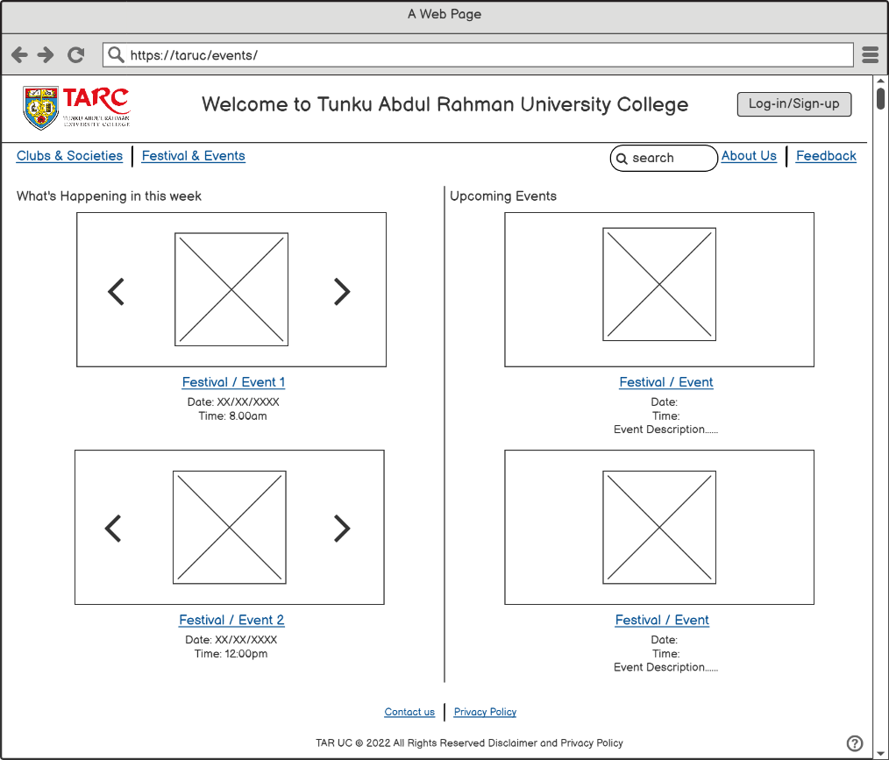

Figure Homepage (Guest)

Figure 1 shows the Homepage of the college events system for TARUC when a user is on the guest mode which shows what are the events happening in the week and the upcoming events. The user can click the Log-in/Sign-up button to access more functions on the website. However, users are also can explore the webpage with not log-in but some functions on the webpage are disabled. Users can click on the ‘Clubs & Societies’ link on the upper left link bar to change to the clubs & societies page to view the Clubs & Societies while clicking on the ‘Festival & Events’ to change to the Festivals & Events Page. Users can also search anything in the search bar and it will filter out all the similar results from the database. ‘About Us’ links to a page that introduces TARUC for examples, the vision, and mission of the college, and other information. However, ‘Feedback’ links to a webpage to let users write and send feedback to the admin through email. The important details like the date and time, and a short description of the event will display on the homepage. Users who want to get more information about the event/festival from the webpage by clicking on the Festival/Event pictures or name. Users can click on the ‘Contact Us’ at the link bar below and that will show the location, contact number, fax number, and email of each TARUC campus. In contrast, the ‘Privacy Policy will display all the terms and conditions of the website, for instance, cookies access and website security.

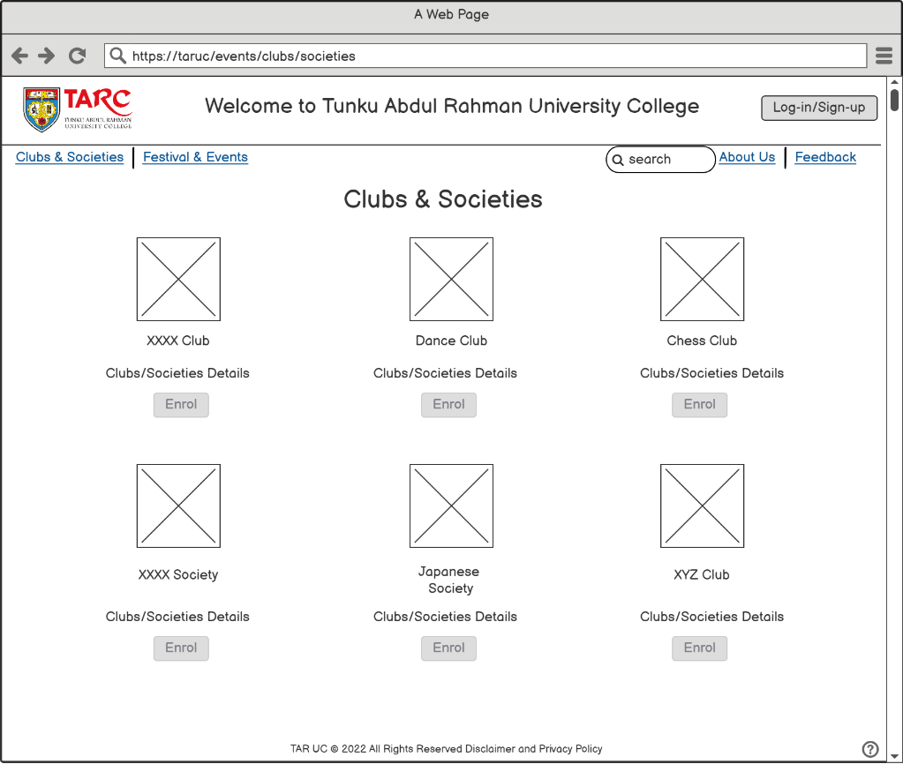

Figure Clubs & Societies Page (Guest)

Figure 2 shows all of the Clubs and Societies for the guest users. The enrol button is disable for the guest users because the users might be not a TARUC students. Non-TARUC student only can view for the club details, photos and others but they can’t enrol in the clubs and societies. Besides that, users can click on the college logo to go back to the homepage while click on club name to view more about the club and society. Other from these functions, other features are same as the homepage.

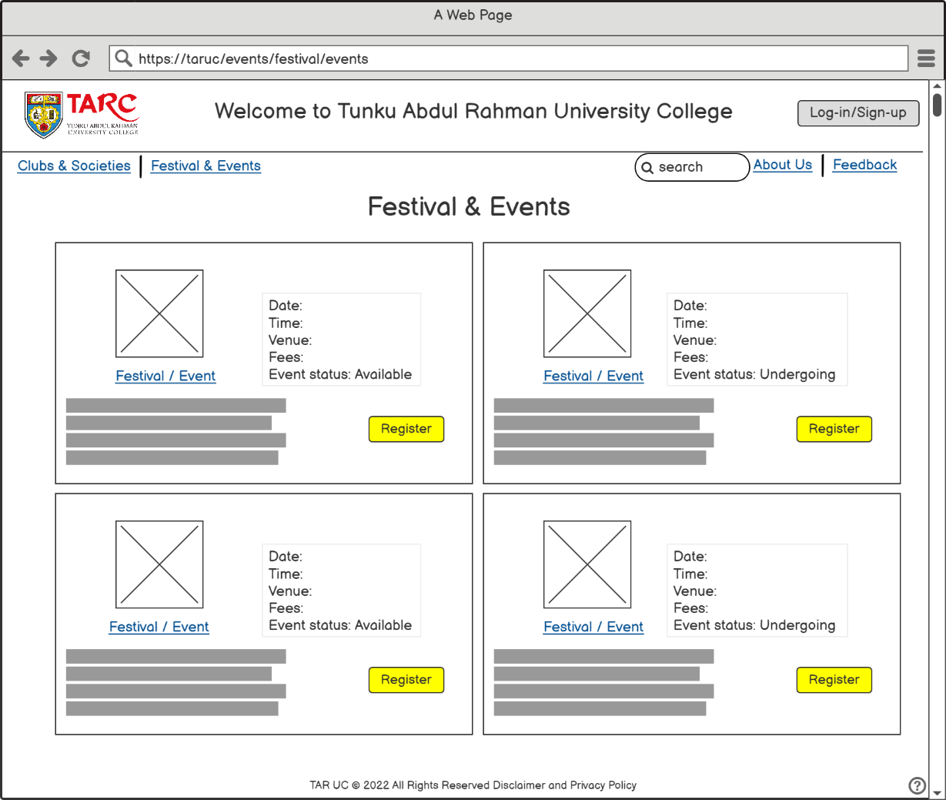

Figure Festival & Events Page (Guest)

Figure 3 shows the Festivals and Events Page for TARUC in guest mode. The users can view and register in the festivals or events that organising. Different with the clubs and societies, for the events and festivals can be register by the guest users. It is because some of the festivals and events are opened for all the college students although the students are not studying in TARUC.

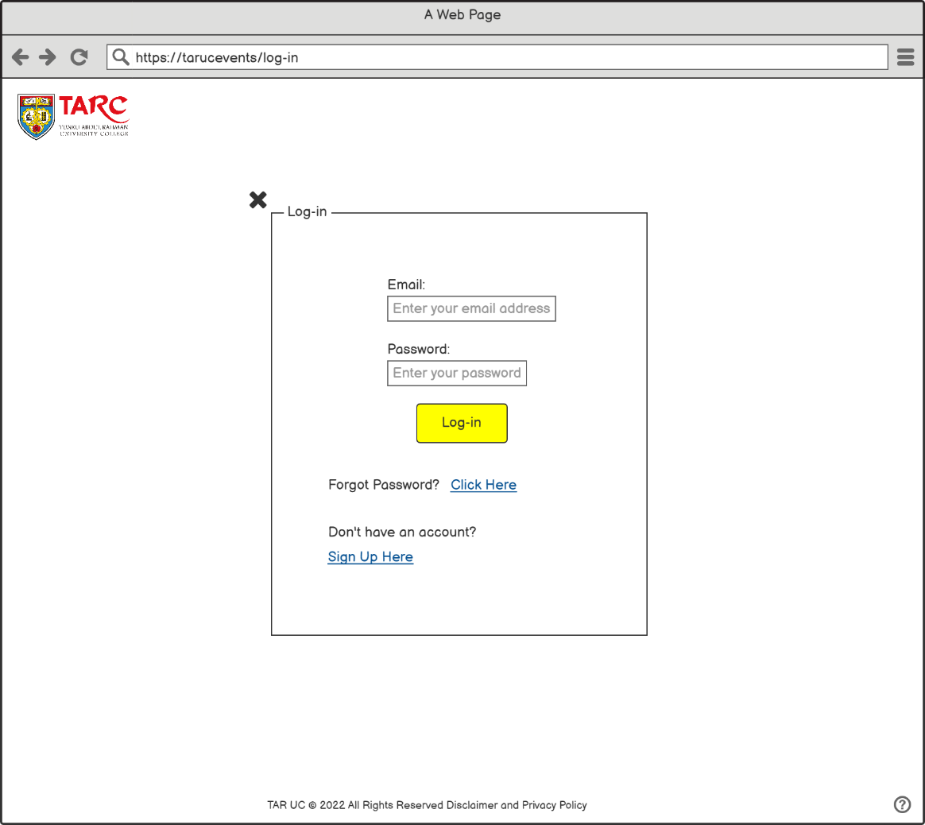

Figure Log-in Page

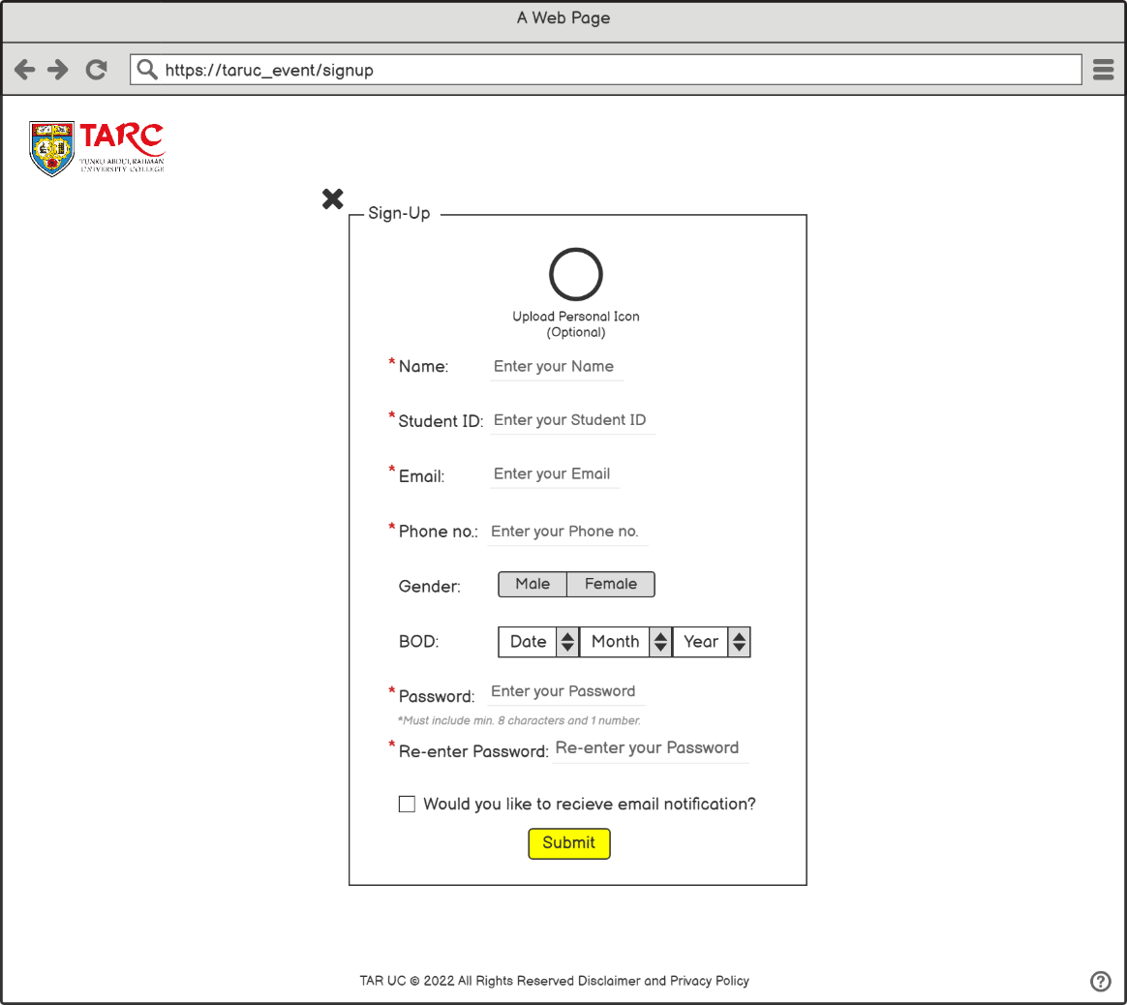

Figure Sign-Up Page

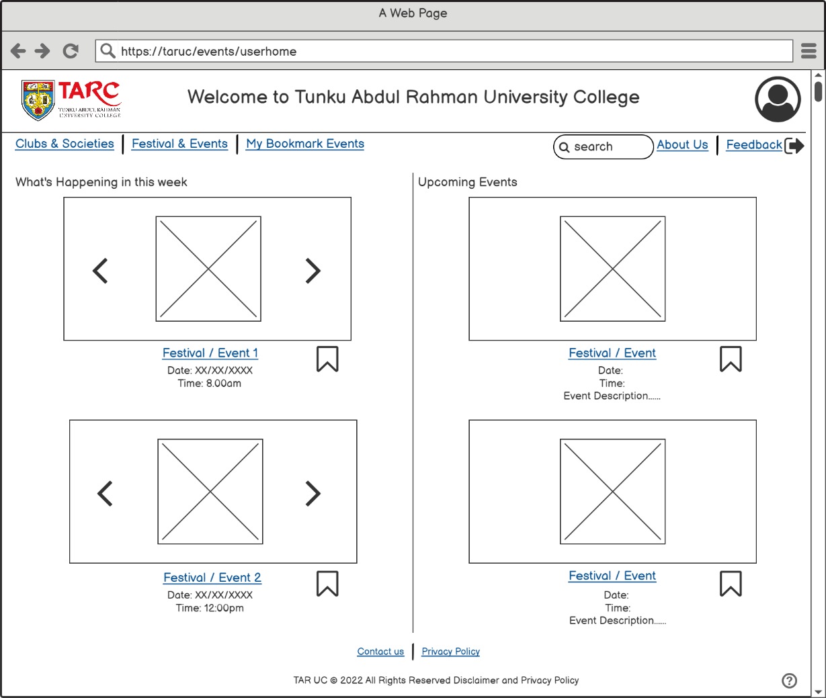

Figure Homepage (Log-in User)

After a user had log-in in to the website, the upper right-hand site log-in/sign-up button will become a user profile icon button. Users can click on the button and then view and change their personal information. The upper left-hand site link bar will add one more function compared to the Homepage for guest user which is ‘My Bookmark Events’. This function let the users save the events/festivals by clicking the bookmark icon and it will show on the My Bookmark Events Page. This function has helped the user no need to searching the events and festivals within all festivals and events for the next time.

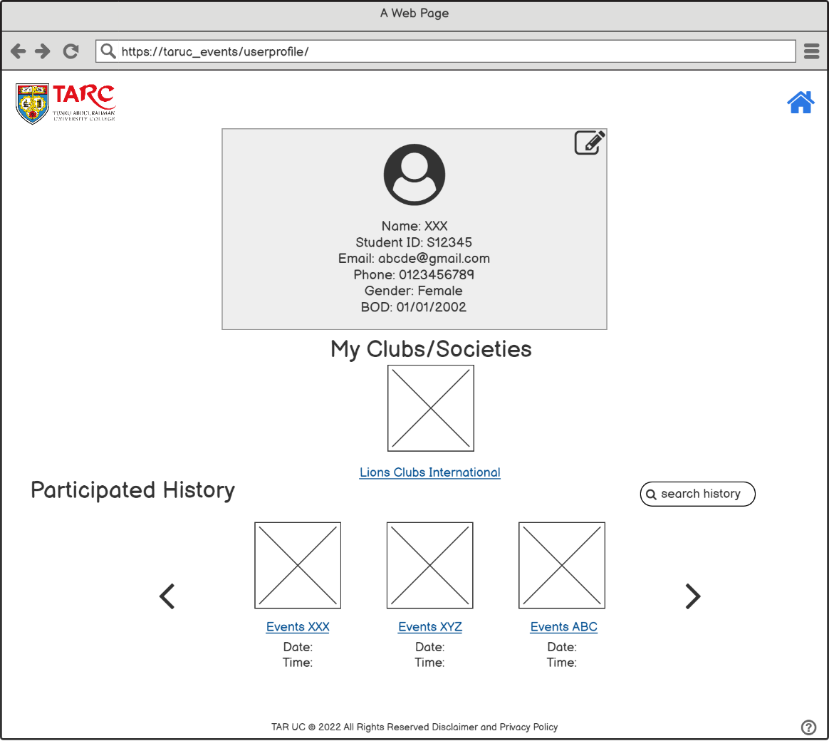

Figure User Profile

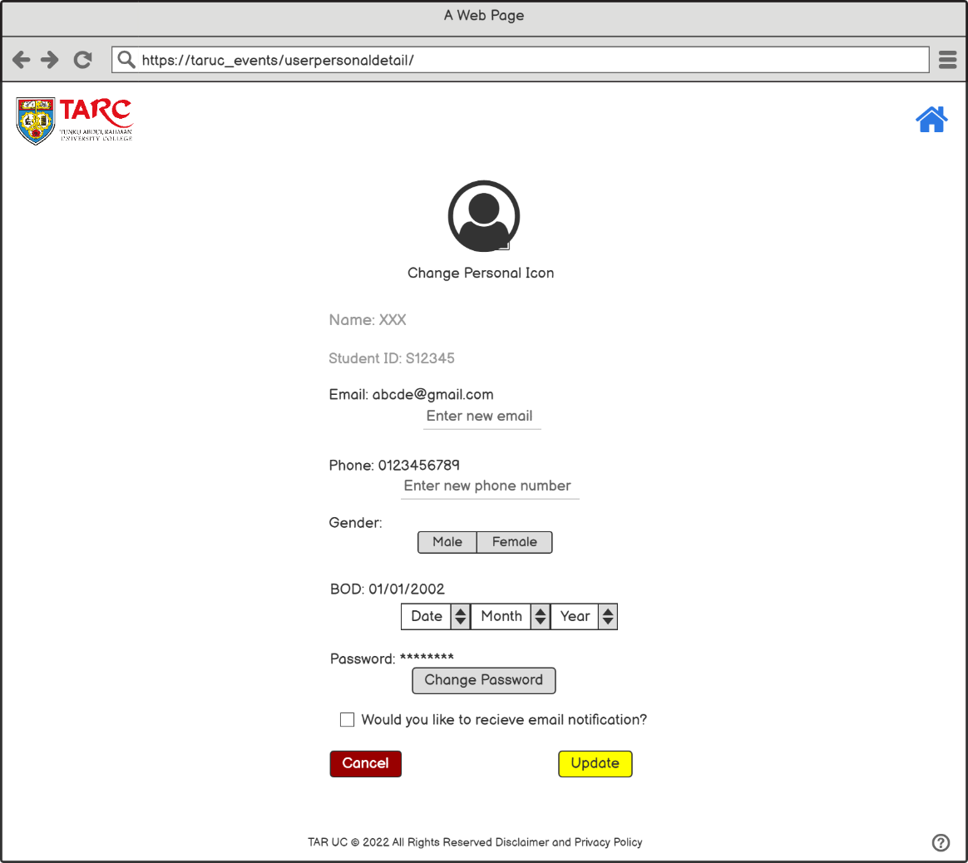

Figure Edit personal details

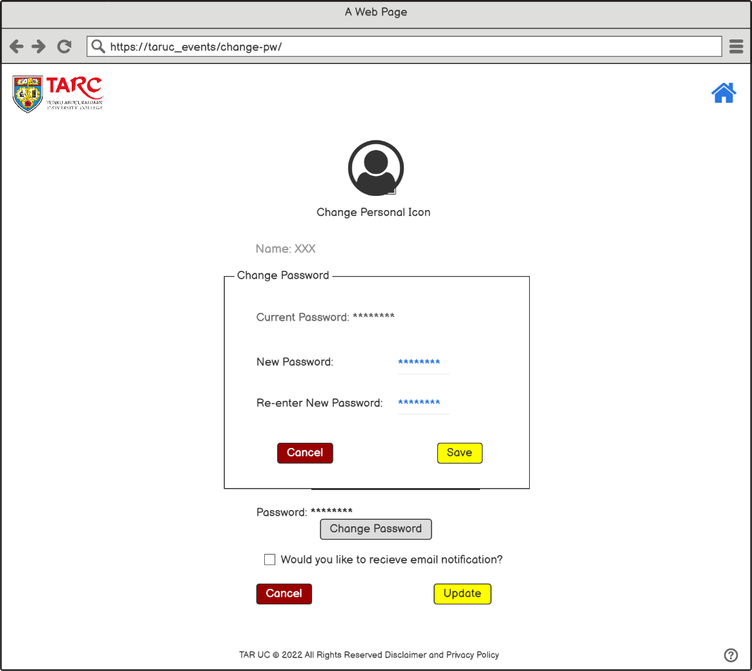

Figure Change Password

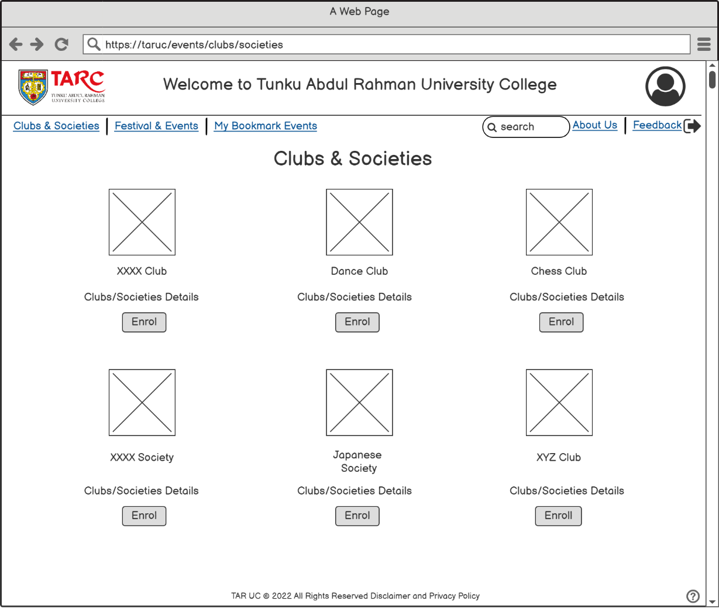

Figure Clubs & Societies Page

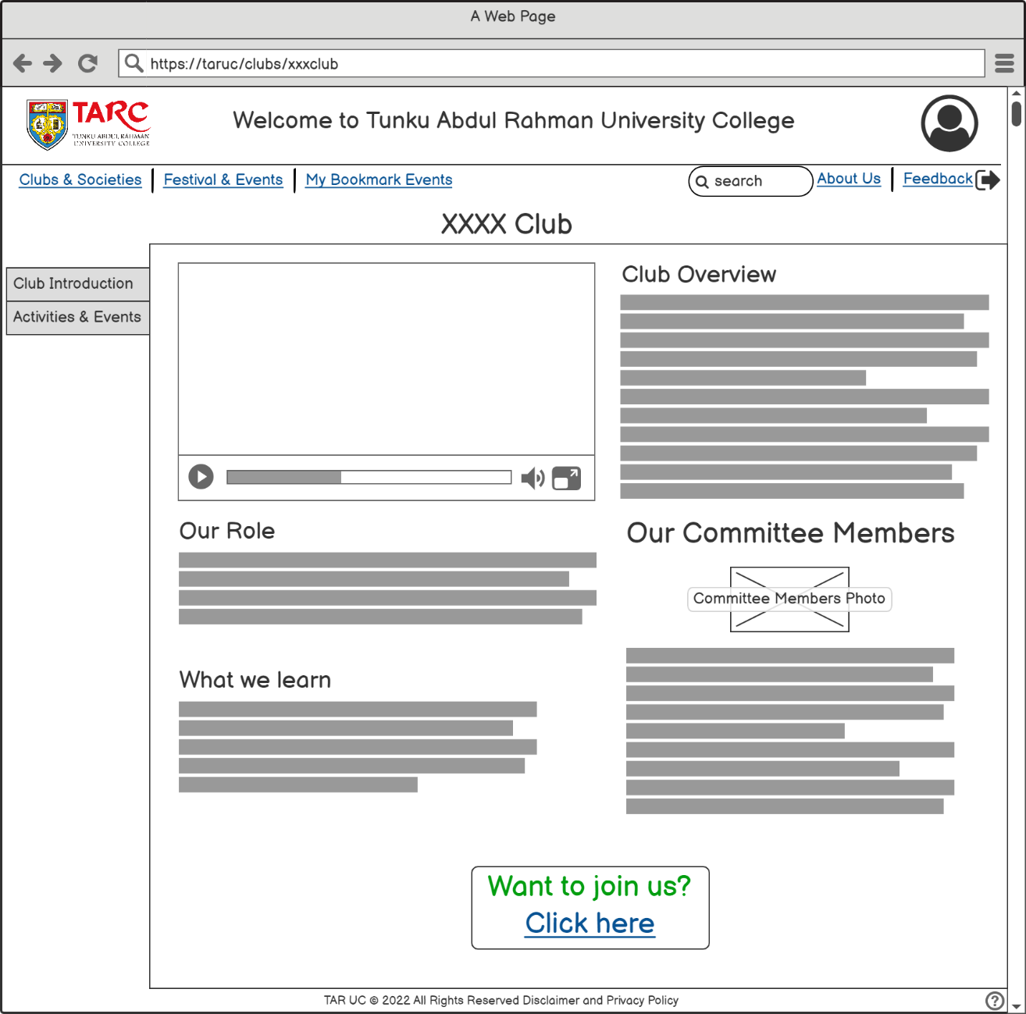

Figure Cub Introduction

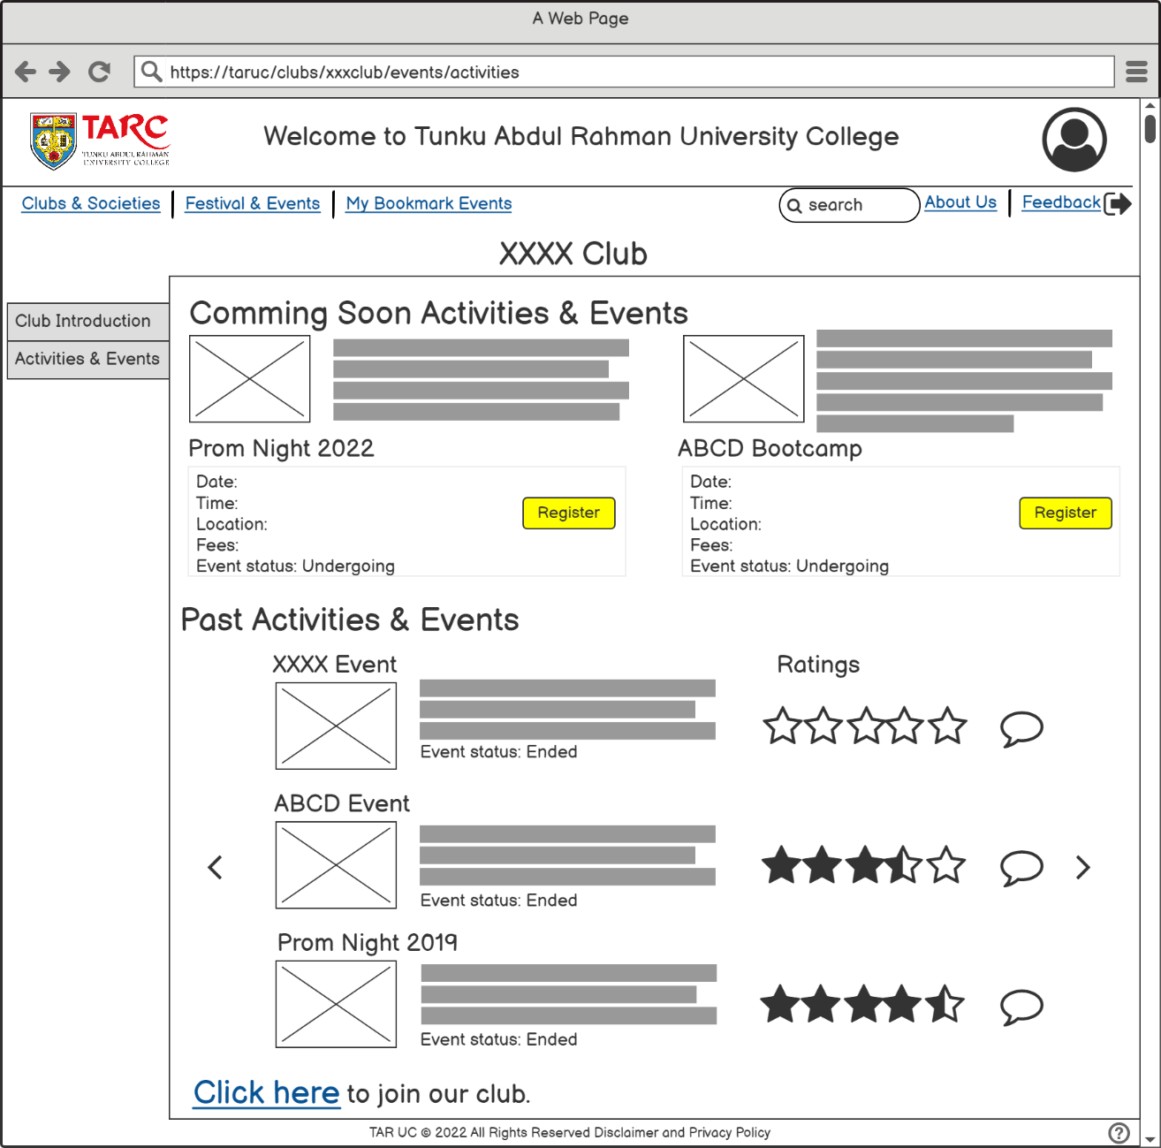

Figure Club Activities and Events

Based on the survey questions in Task 1, Question 5 asked what are the features or functions that a user would like to see in this system. There are 9 responses out of 20 responses (45%) choose that they would like to enrol in the clubs and societies. Figure 10 shows all of the clubs and societies of the college with a short description of clubs while Figures 11 and 12 show the club introduction and the activities and events hosted by the club or society. A vertical tab has two tabs which are the club introduction and activities & events hosted by the club. This vertical tab is to let users easily view the club details. At the club introduction tab, users can view the club introduction video and club details, for example, the club overview, role of the clubs, what can we learn from the clubs, and others. On the other hand, the user can view the upcoming activities and events and all the past activities and events organized by the club. Users can view the events details by clicking the events name while clicking the register button to register for the upcoming events. If the user clicks on the past events, users can view all the activities/events photos, after events reports, and view the rating and comments written by the participants. If a student is interested to join a club or society, click on the ‘click here’ that is in blue which is a link to an enrolment form. In addition, for those who want to go back to homepage just click on the college logo then it will proceed back to the homepage.

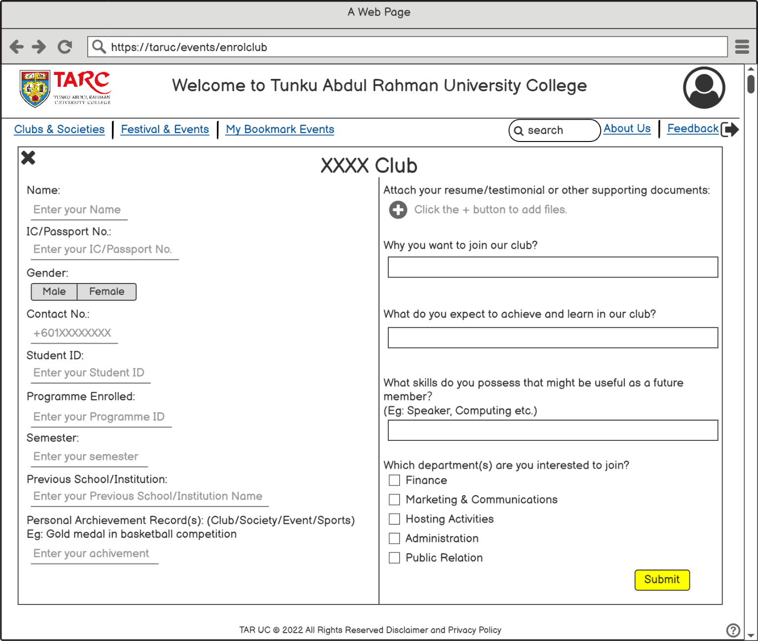

Figure Club enrolment

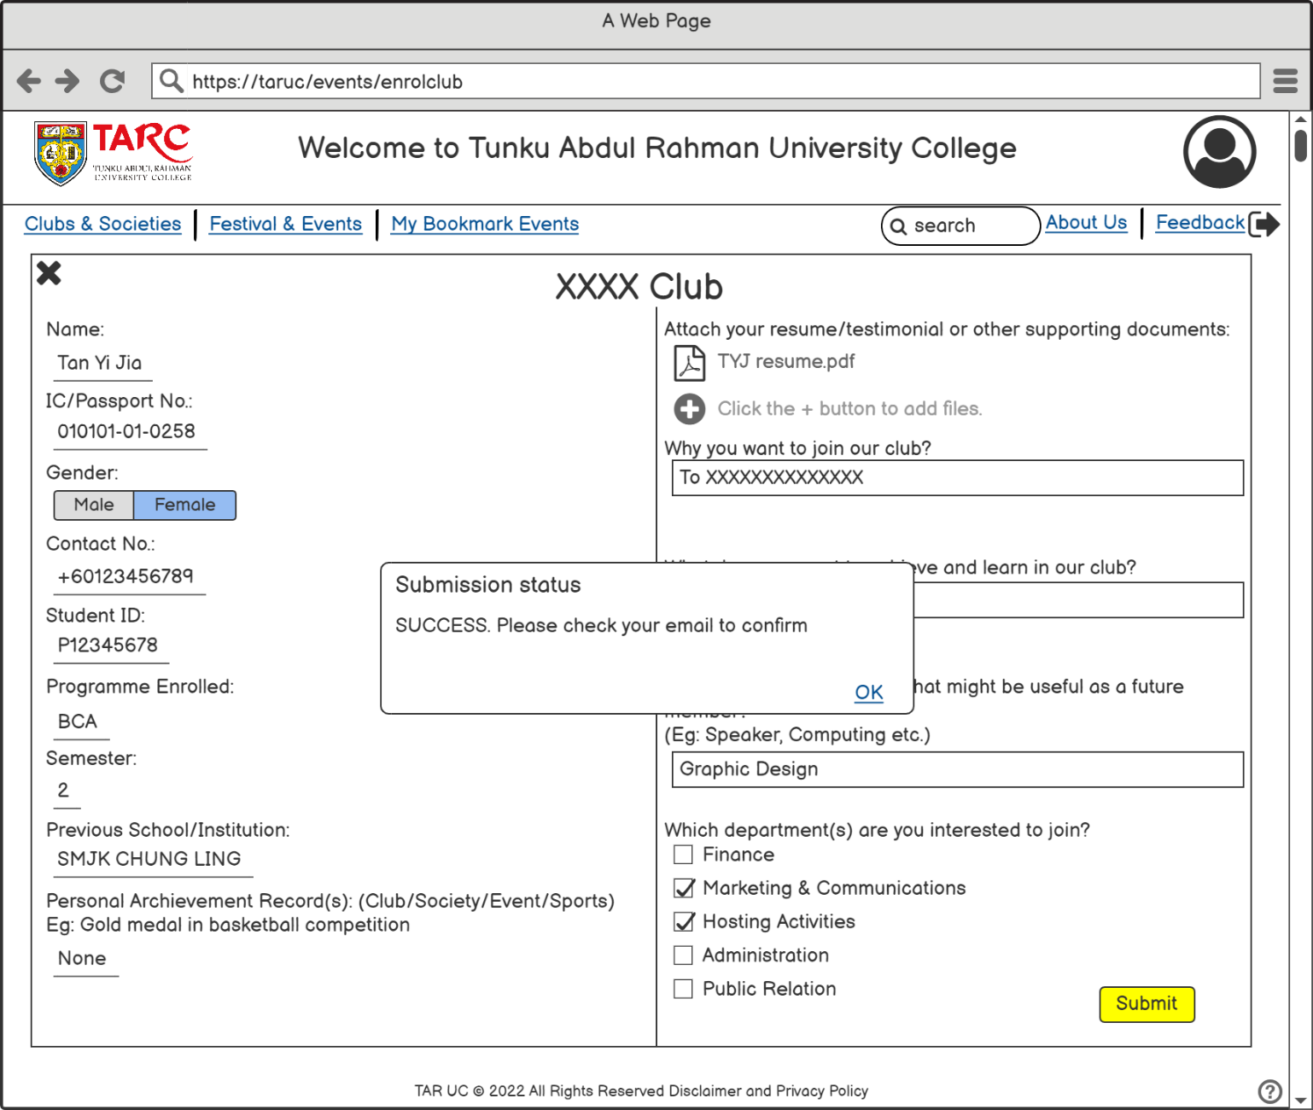

Figure Enrolment successful

After the user clicks to enrol in the club, the user is required to fill in the forms and submit them. A user who wanted to become a committee member must attach supporting documents, for example, a resume and testimonial. This is to let the club committee choose a new committee member who is suitable to work together in the society/club. After the submission success, it will pop up a small blocker that written submission status is success as shown in Figure 14. The user will also receive a confirmation email after the submission is success.

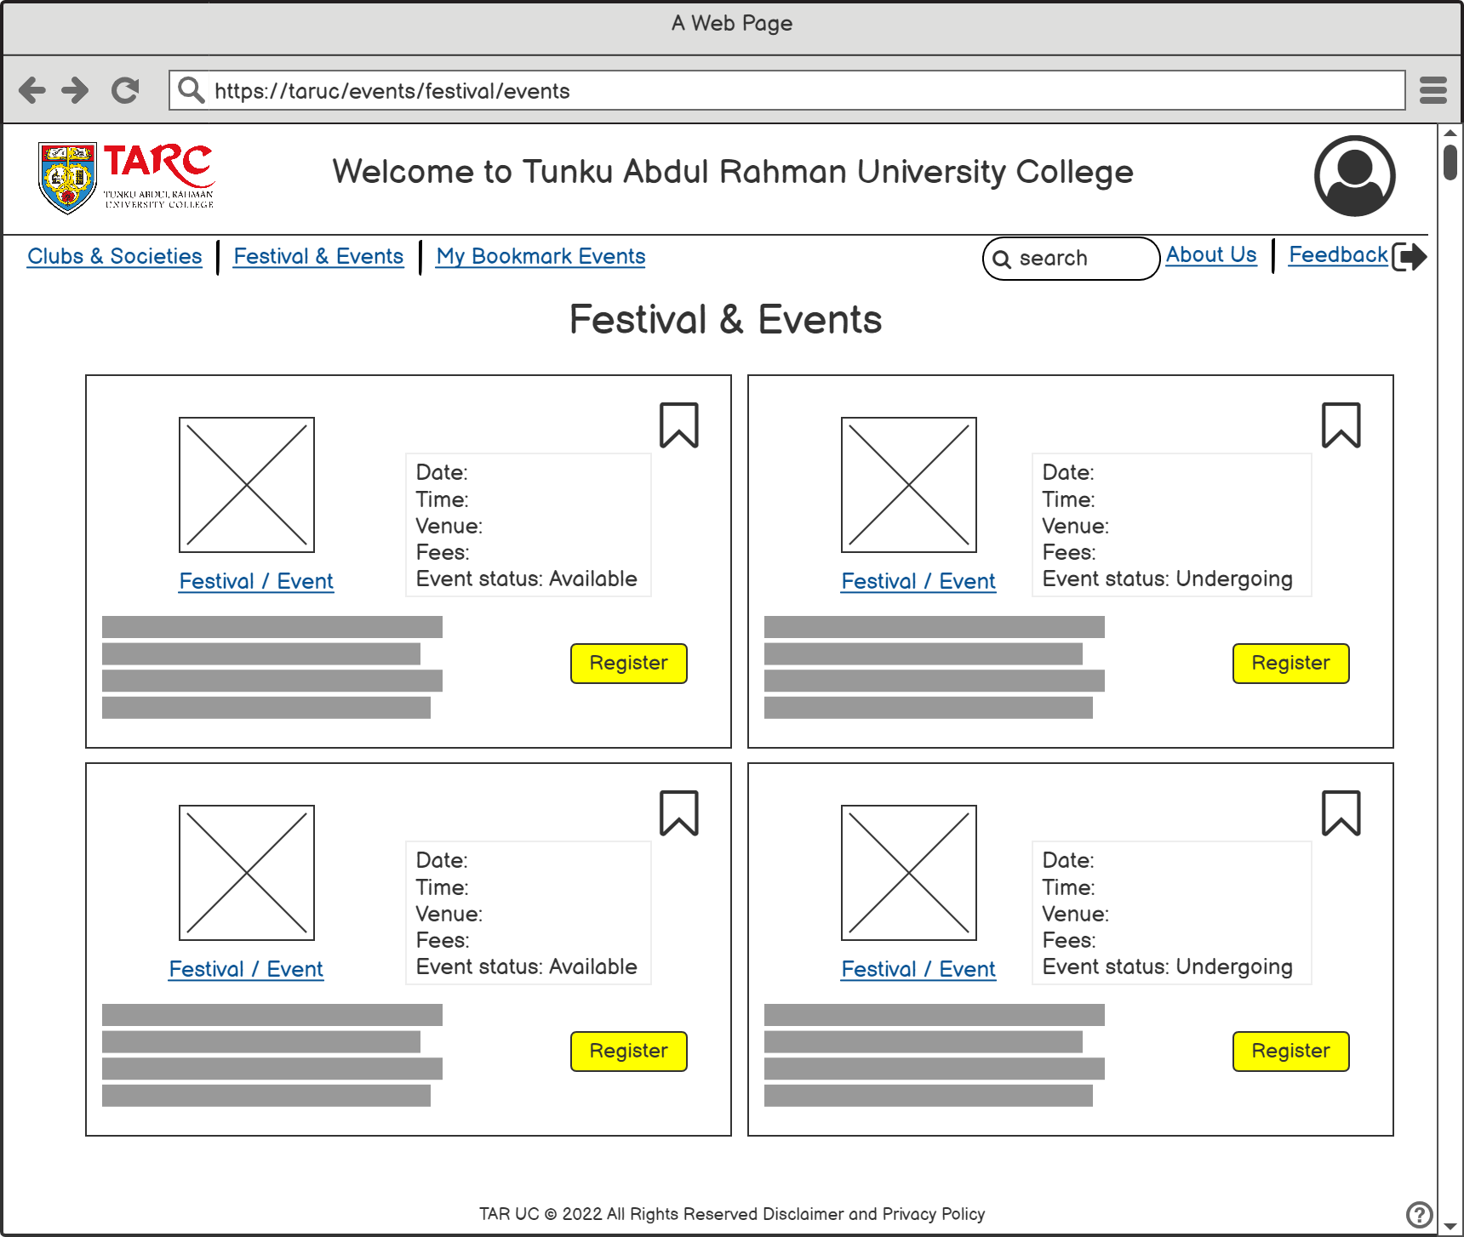

Figure Festivals and Events Page

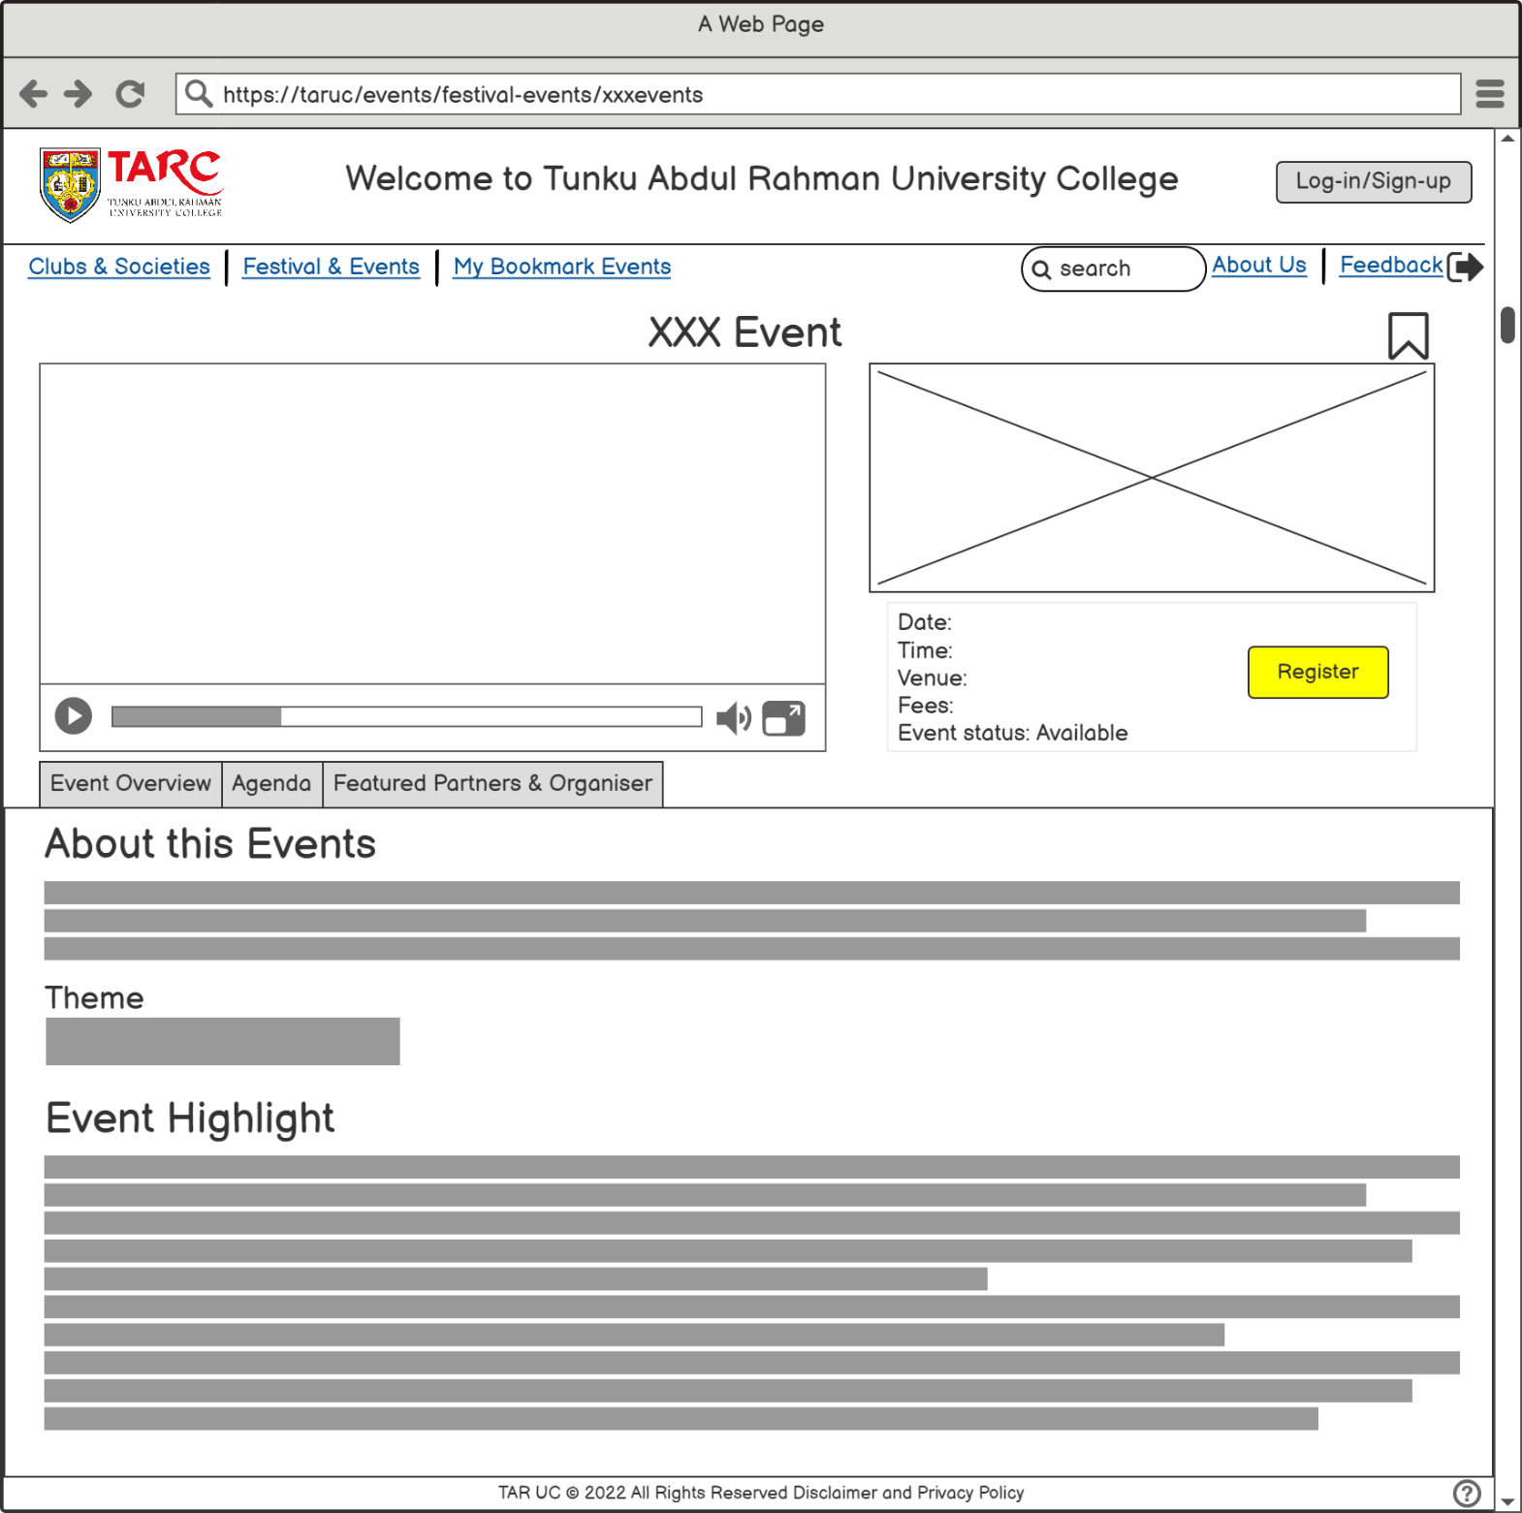

Figure Event Overview

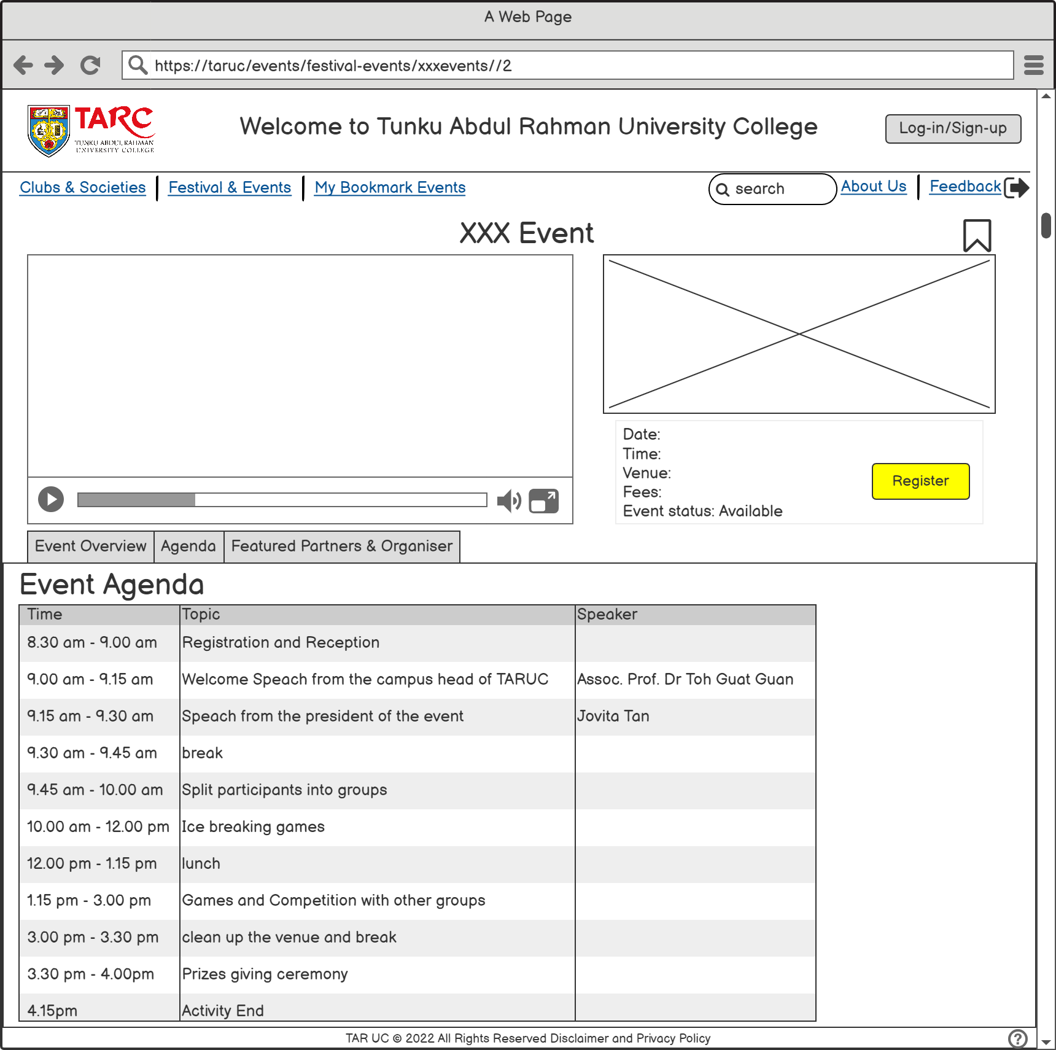

Figure Event Agenda

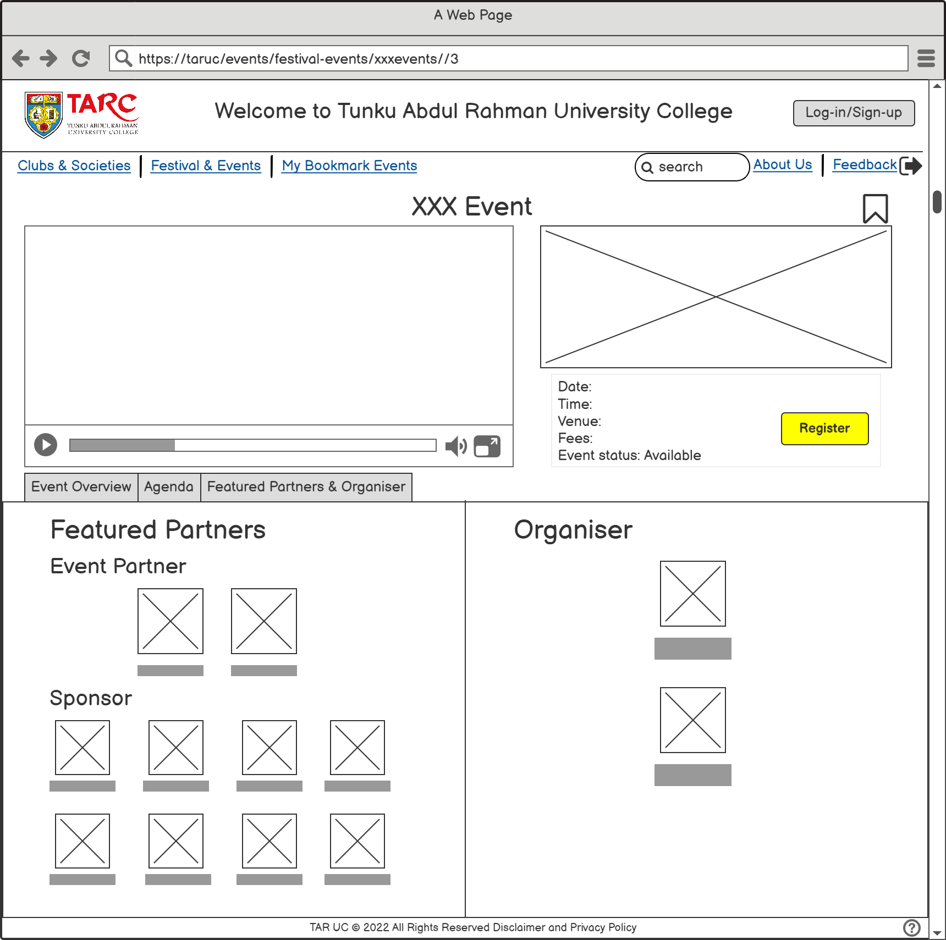

Figure Event Organiser and Partners

Based on the survey questions in Task 1, Question 5 asked what are the features or functions that a user would like to see in this system. Based on the survey, 85% of responses (17 responses out of 20 responses) choose users can register in events while 14% of responses (14 responses out of 20 responses) choose that a user can view the events. Therefore, these two functions are the most important features and functions in the system. Figure 15 shows all the events that hosting by the college while Figure 16 to Figure18 show the interface design for the event details, for example, the overview of the event, agenda of the events, and the featured partners of the event. Firstly, users can review all the events and festivals that are holding or coming soon in Figure 15. Posters of each event with a short description, date, and time are published on the page instead of putting long information on the festivals and events page. This will cause the users lost interest in reading so many texts. Besides that, users can save their interested events by clicking on the bookmark icon on the right-hand site. After clicking on an event, users can watch the promotion video of the events and view the poster of the events on the webpage. The important information like date, time, and venue are listed below the poster so that the user can straight receive the information without searching and exploring the whole webpage. A menu bar is also included below the videos and posters which labeled the event overview, agenda, and featured partners & organizer. This menu bar is to let the user can see other information that they are interested in easily and quickly rather than scroll the webpage down to find the information. Thus, the user may click the Register button to register for the events by filling out the registration form.

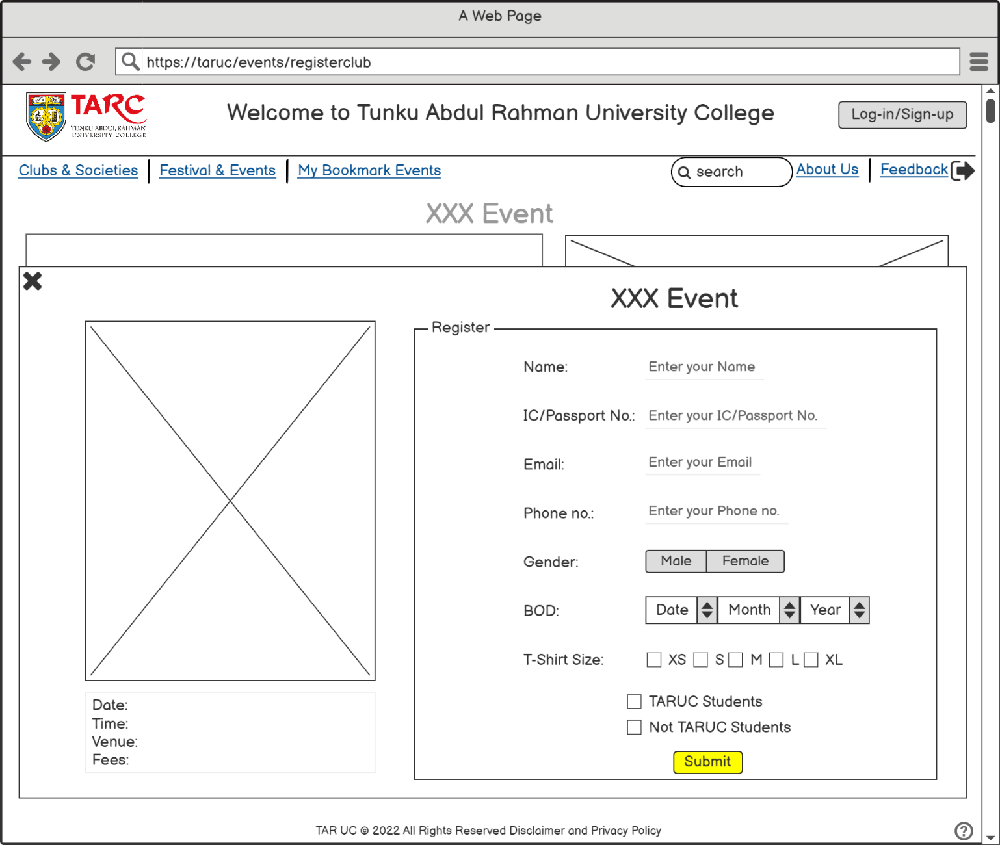

Figure Event Registration

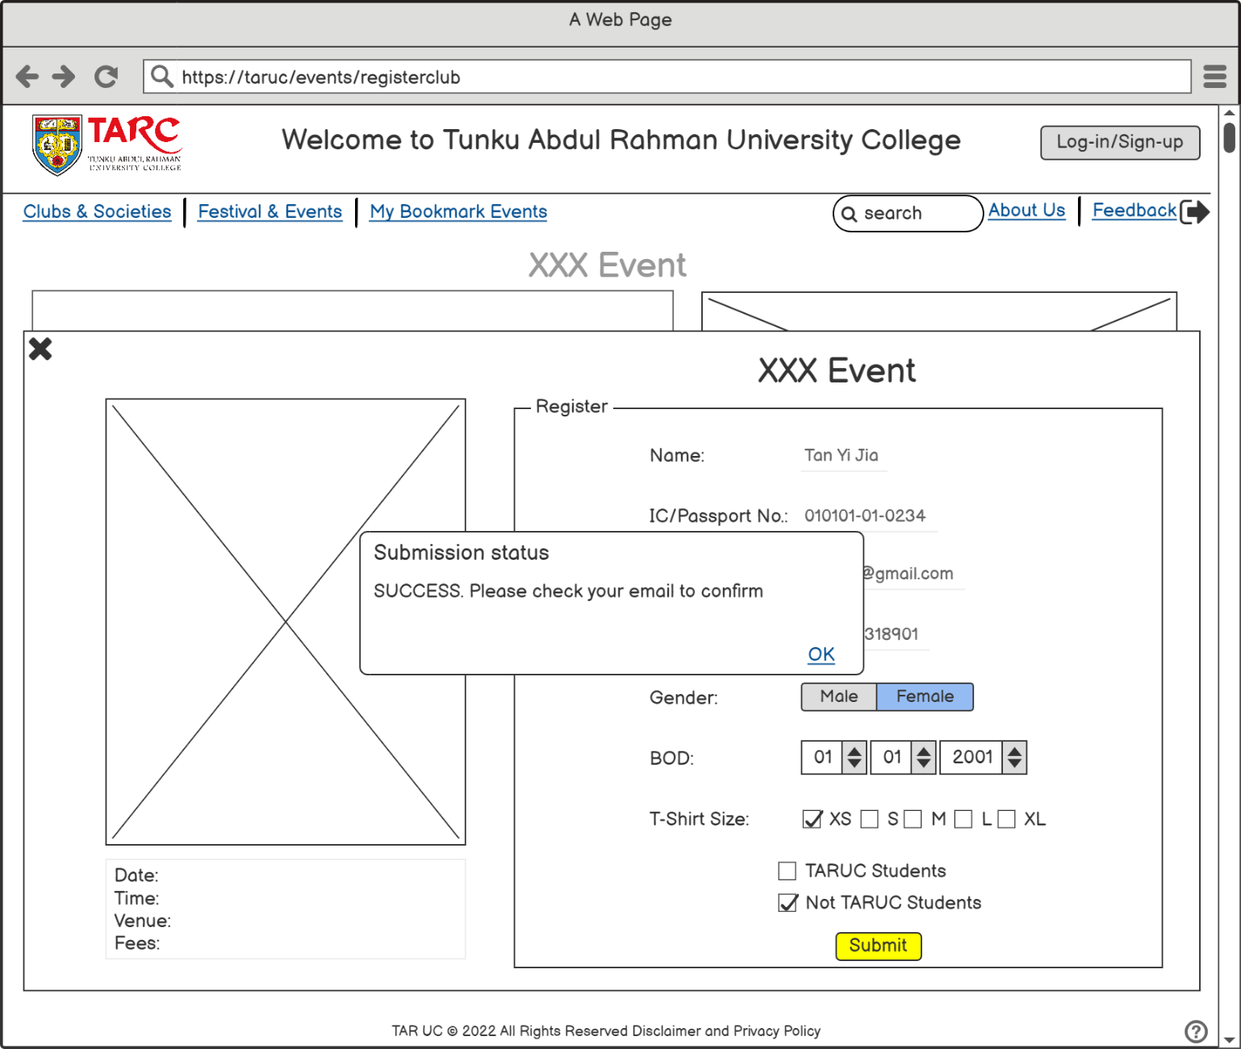

Figure Registration successful

Figure 19 is the registration form for the user that want to register in events. User are required to fill in the all the fields, for example, name, NRIC, email address, phone number and other information that need by the organizers to register in the event. After that click on the submit button to submit the form while click the cross on the left-hand site to cancel. However, for the user who want to back to the previous page just needed to click the cross which on the left-hand site. After submit the forms, for some events or festivals that need to pay fees will proceed to a transaction window to do the transaction. Lastly, A confirmation email will send and a small blocker will pop up that shows that the user is successfully register in event.

## **Usability Testing Questions**

For question 1 to 4 tick for your opinion based on the question on a scale of 1 to 5 (1 = Poor/Never, 2 = Fair/Rarely, 3 = Satisfactory/ Occasionally, 4 = Very Good/ Frequently, 5 = Excellent/Very Frequently).

|  |  |  |  |  |  |  |
| --- | --- | --- | --- | --- | --- | --- |
|  | Questions | 1 | 2 | 3 | 4 | 5 |
| 1 | How was the experience using this website? |  |  |  |  |  |
| 2 | How did you think on the design and layout? |  |  |  |  |  |
| 3 | How frequently would you use this website? |  |  |  |  |  |
| 4 | Is the website clear enough? |  |  |  |  |  |

1. Were you able to find all the information you were considering for?
2. Did you encounter any difficulties while browsing the website?
3. If you could change one of the features, which features would it be?
4. How can I improve the website?

## Appendix

1. Prototype link. https://balsamiq.cloud/ss4sz4/paxtcpc